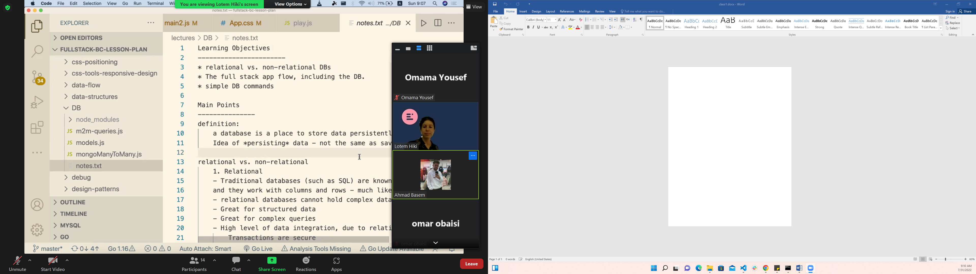

Coloms=== properties

Row === one entity

Relation between 2 table

Realeations ship between tables ==== 1-1,1-m,m-m

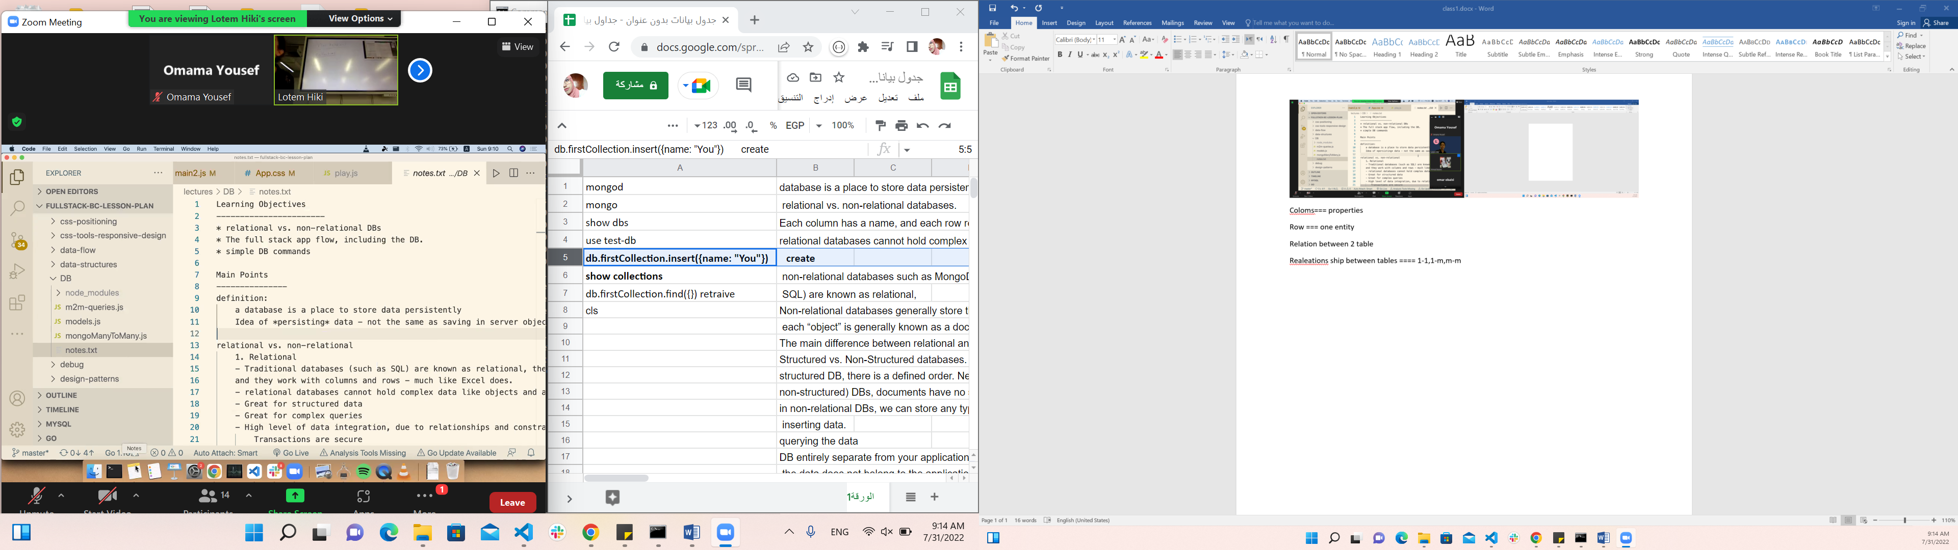

Non releation db

Collection json

Array 1-m in sql to get an array of students

What is scal dB ???? how to change the capacity of DB ?? performance!! Storage is the problem with sql

Ram

How we extend the memory??

Us enothor computer to store data

Horizontal scaling non releational database ()

Vertical scaling relational we need data base in the same play and it hard to join computer.

Flexability of data

Types of data

Scalin of data

Big data====extract data I wouldn’t to filter or any thing but give me data

Restriction in sQl relational db, a lot of validation

Relational each entiti to a

Non relatu=ional =🡺>> easy to add property in the future

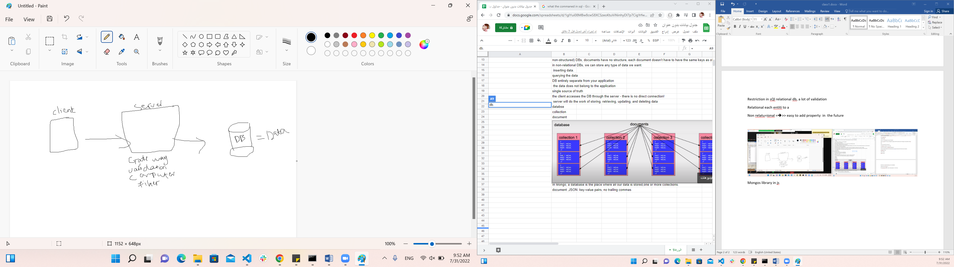

Mongos library in js

ORND =====🡺 to do list

]

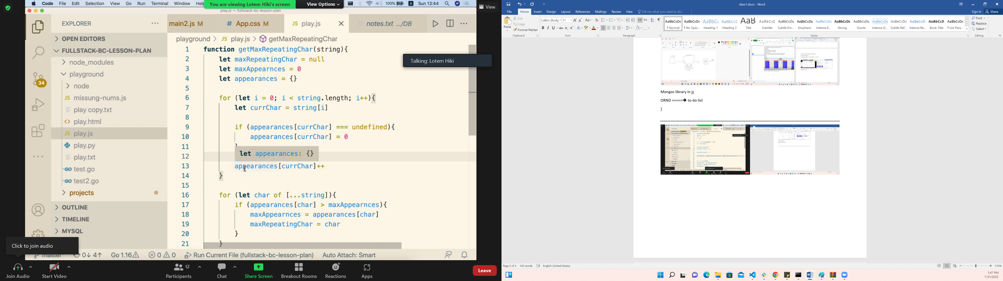

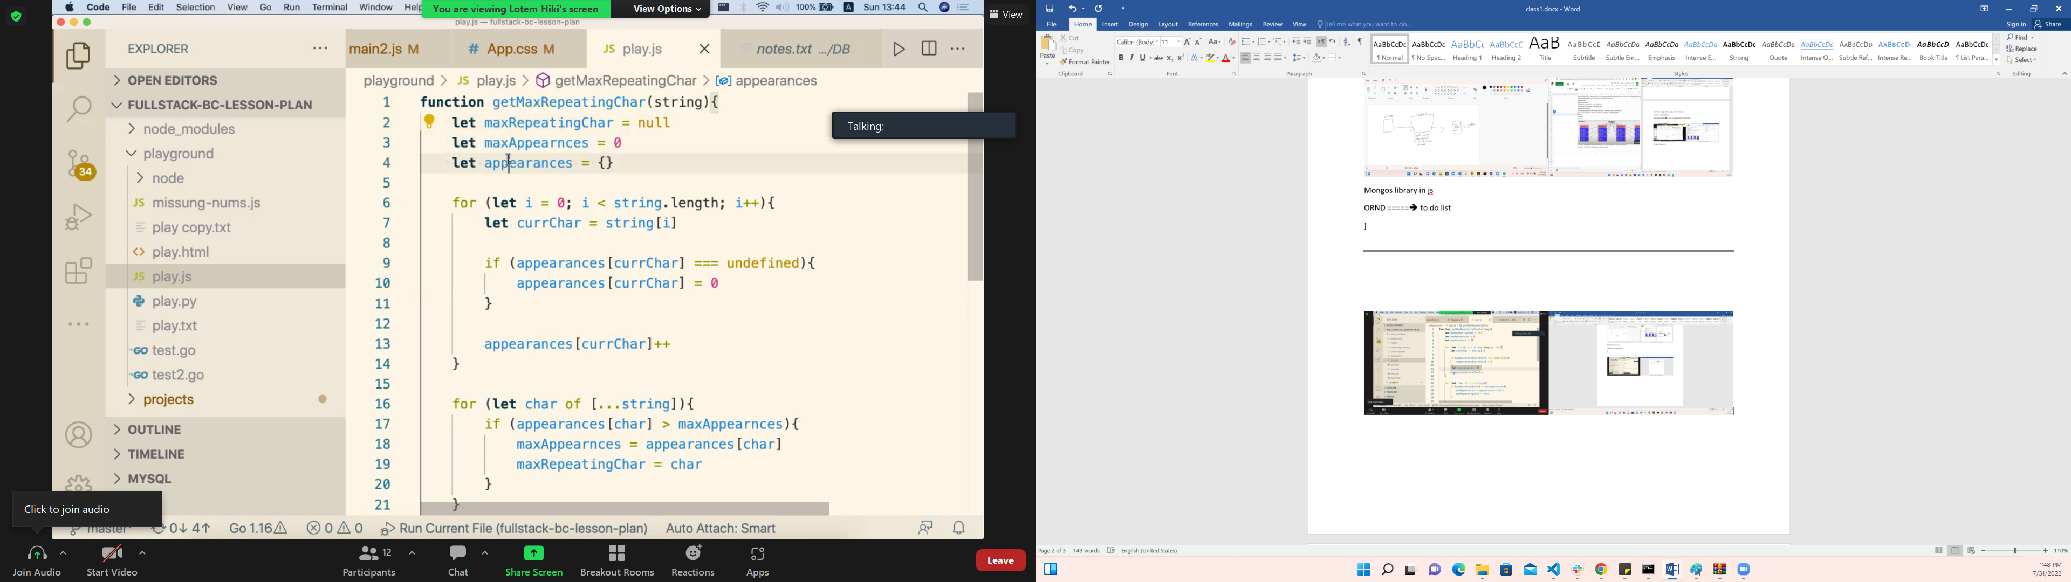

9-8-

Groups 3 ides

What is the product

Features

FullStack Api, DB, MongoDB, Express,

Tuesday groaps

Wednesday

Tuesday we start

Lotem teach us how to write the code and run it then make a code on it not to write a code without run the consept run easy code then add many thing on it